**Logic Design, Fall 2013**

Verilog Lab0

1. Connect to Lab 231 workstation

* Website: <http://cad.ee.ntu.edu.tw>

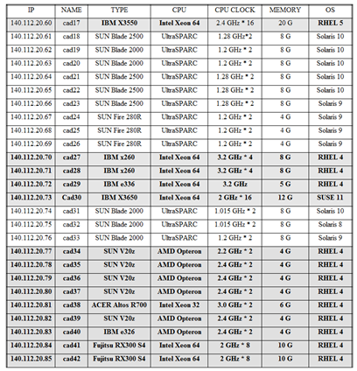

* File transfer software – FileZilla

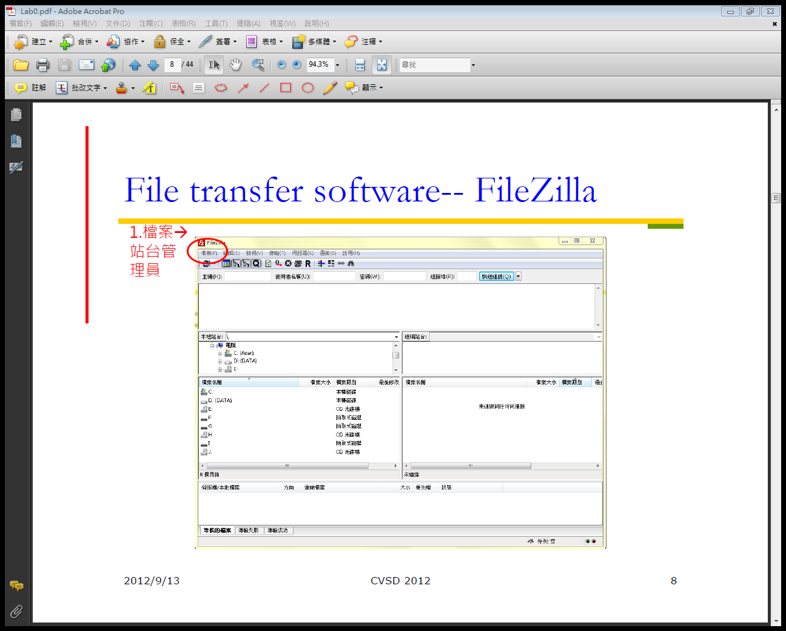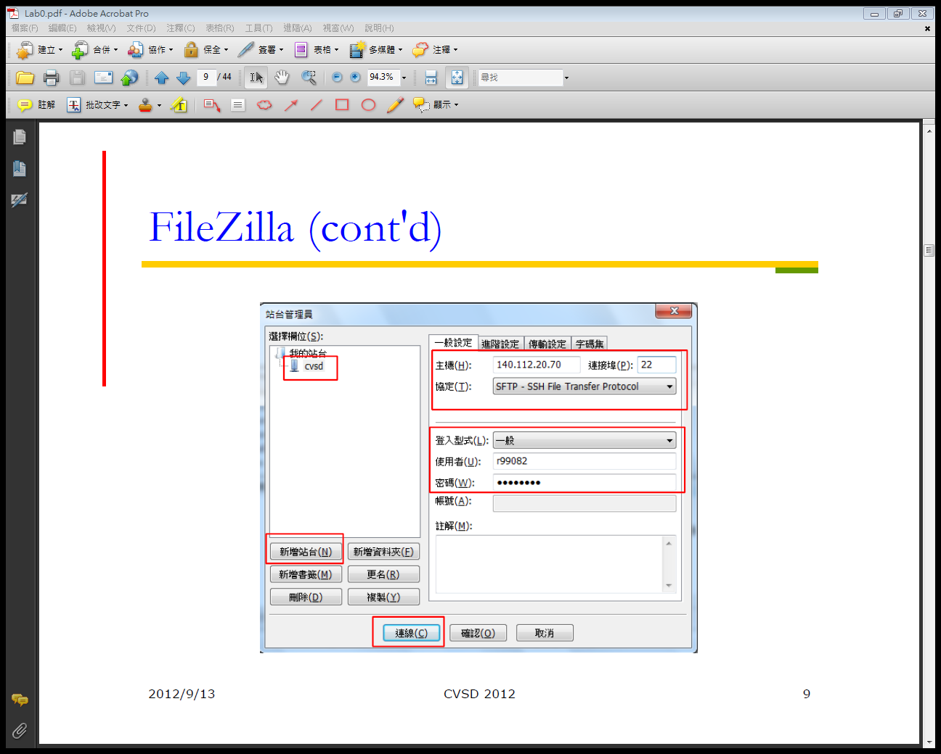

* MobaXterm

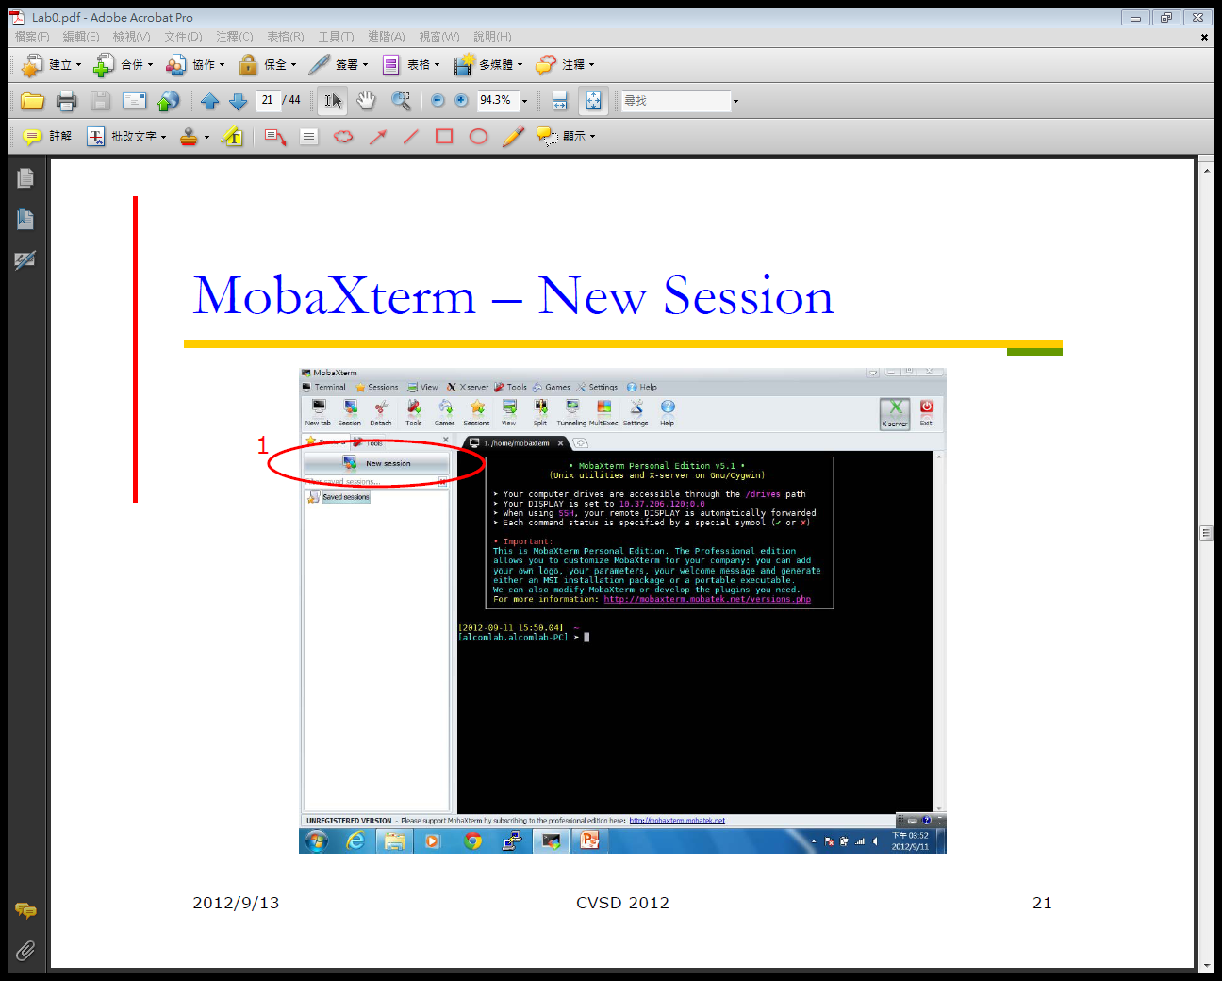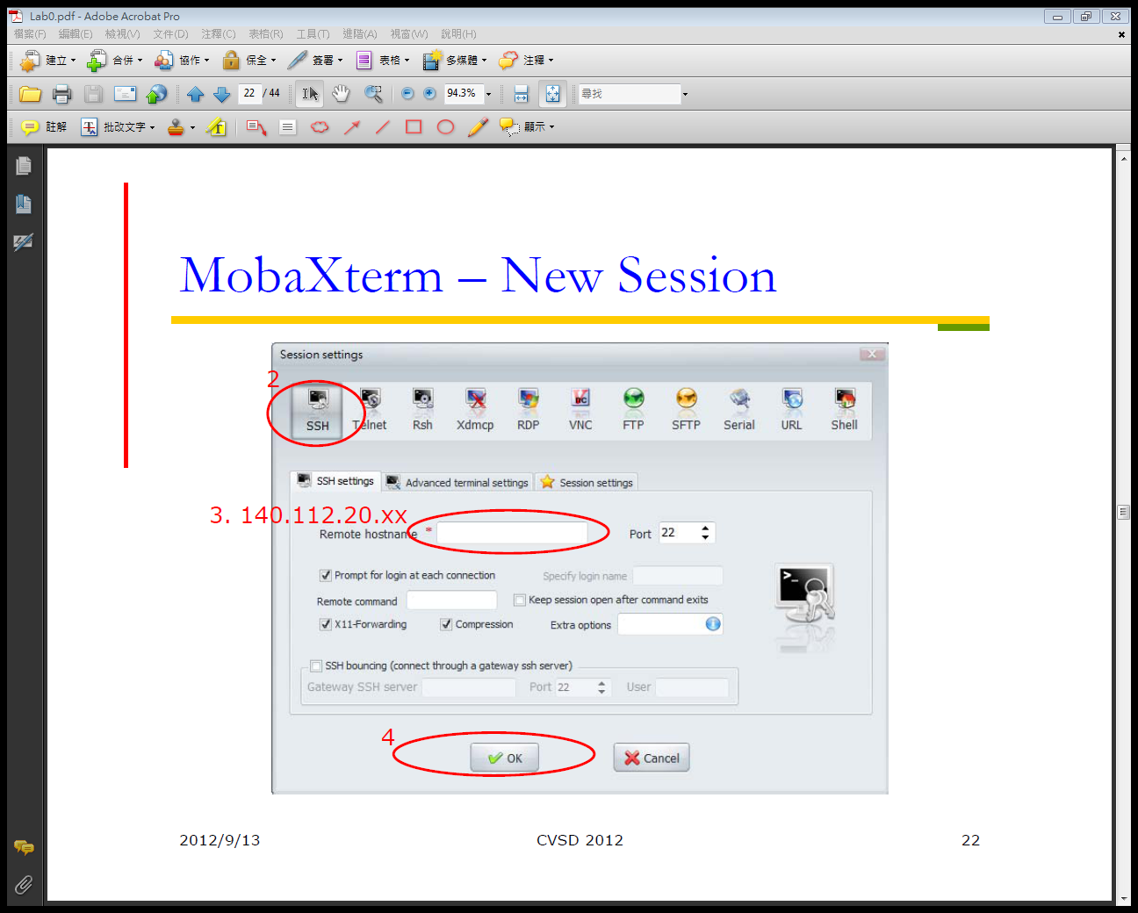

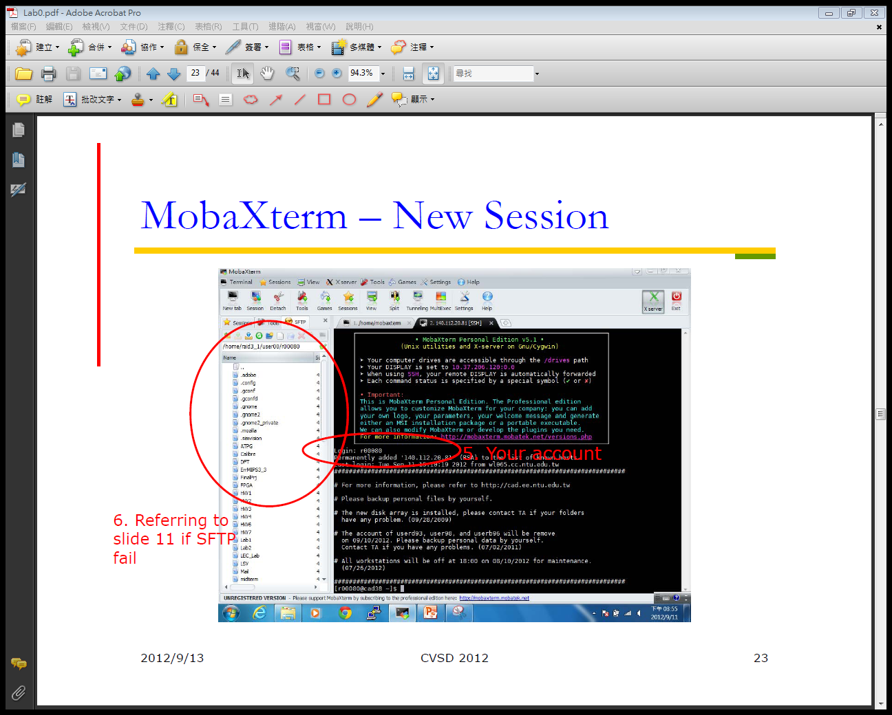

1. Basic commands

* Files
  + ls: list your files
  + ls –l: lists your files in long format
  + ls –a: lists all files, including the ones whose filename beginning in a dot
  + cp src-file dest-file: copy files
  + mv src file dest-file: move files (rename)
  + rm filename: delete this file
  + more filename: show the content of the file
* Directories
  + mkdir dirname: make a new directory
  + cd dirname: change directory
  + cd ..: go up on directory level from here
  + cd ~: do to users’ home directory
  + rm –rf dirname: remove a dir
* Compress and decompress files
  + tar –cvf filename.tar filename: compress
  + tar –xvf filename filename.tar: decompress
  + man tar: get more information about parameters
* Process
  + ctrl + c: fill foreground process
  + ps: report processes and their pid number
  + kill pid#: kill the process with the pid#
* Logout
  + exit

1. Wave
   * nWave

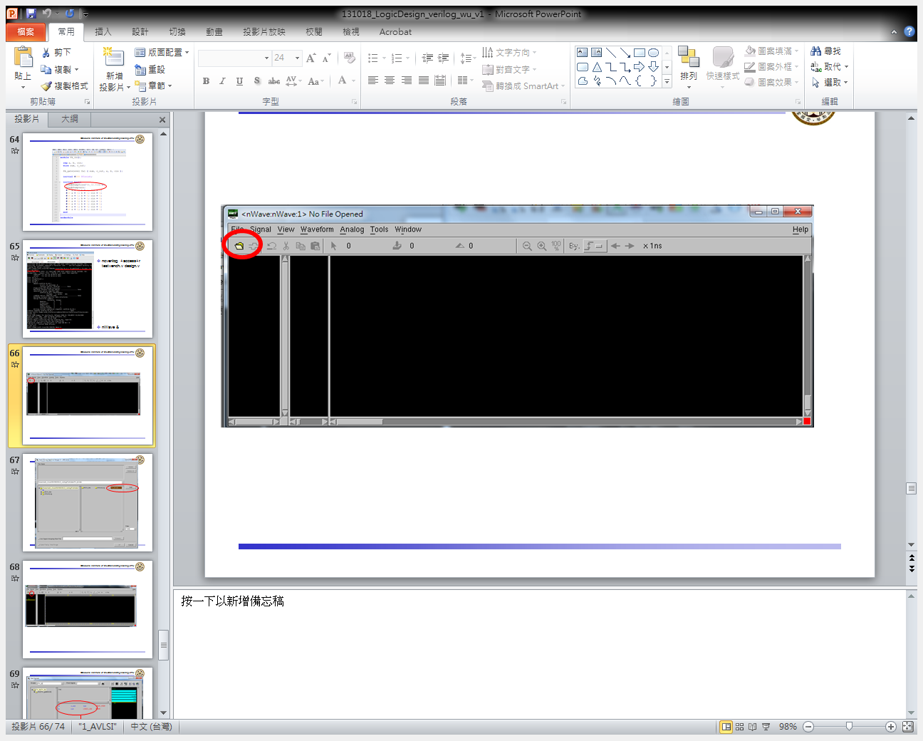

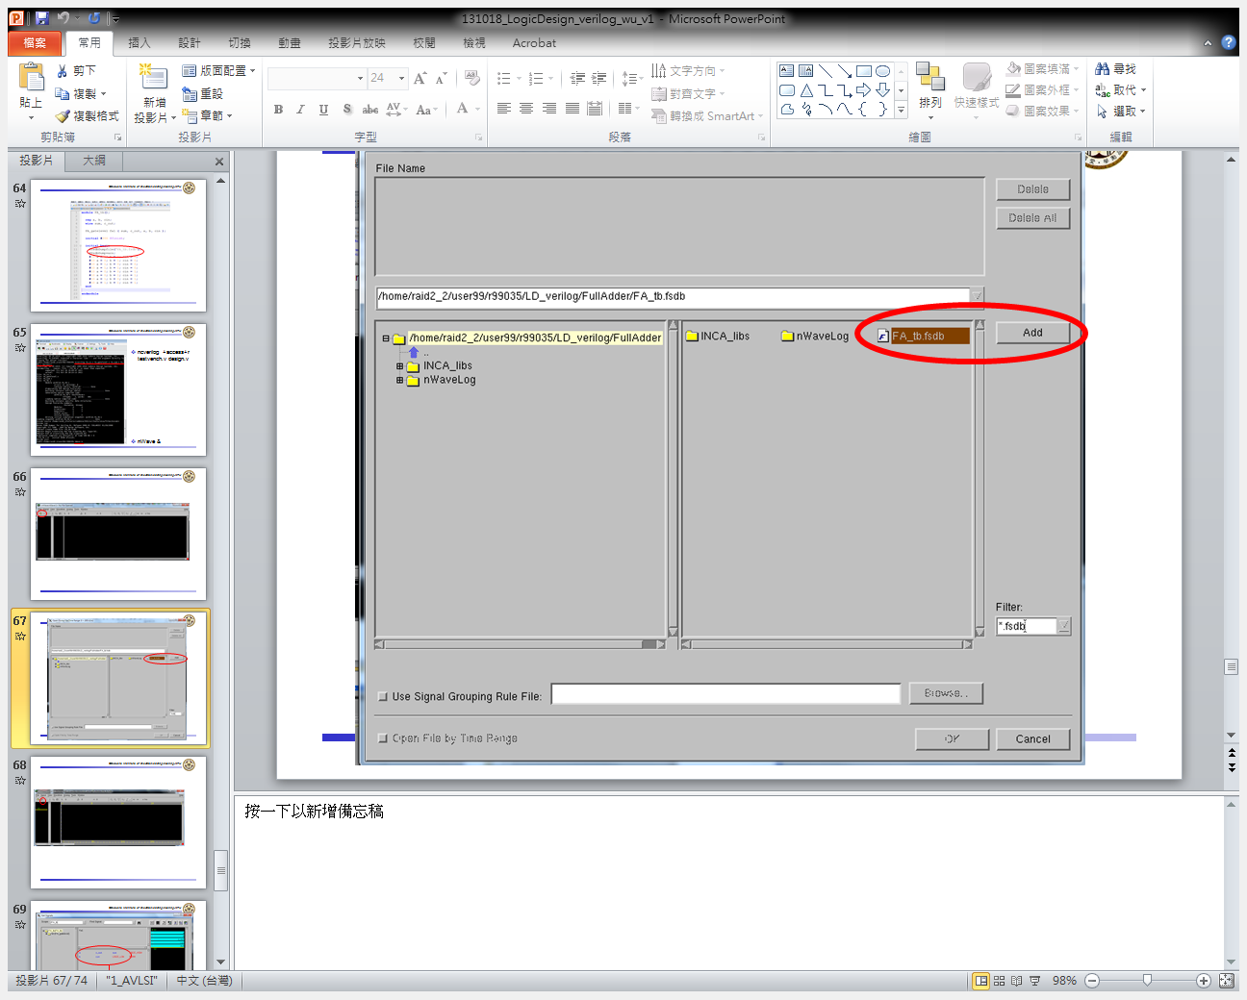

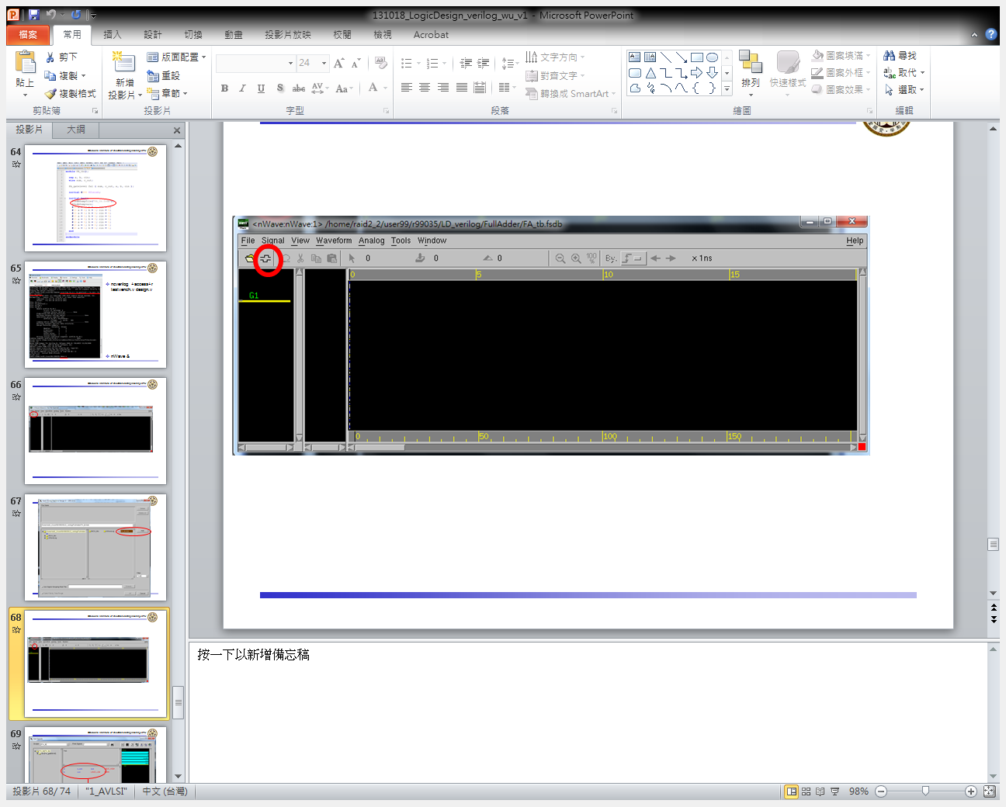

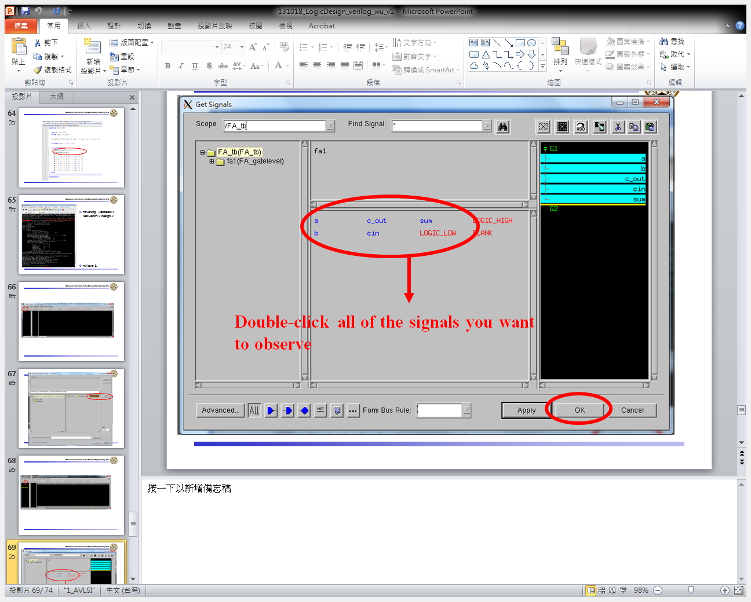

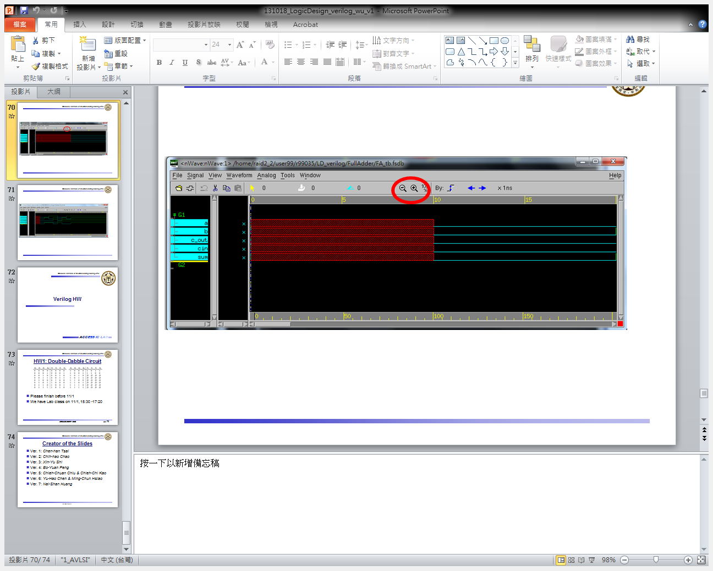

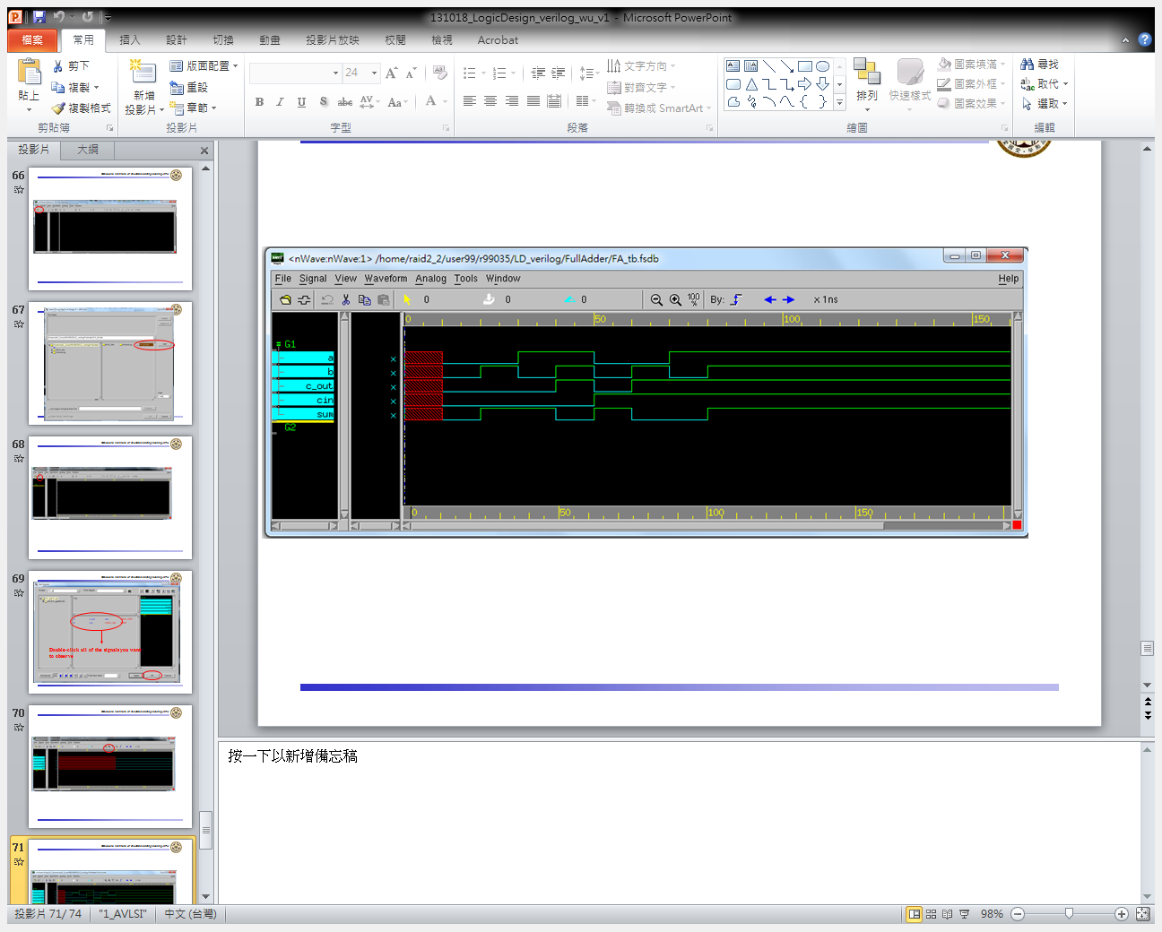

1. Editors

* Notepad++

